**External Events**

**Conferences Attended by the Department of Economics**

**Lahore School Faculty Attend CSAE Conference 2015**

Researchers from CREB presented papers at the Centre for the Study of African Economies (CSAE), Annual conference held on March 22nd - 24th 2015. The Centre for the Study of African Economies (CSAE) is an economic research centre within the Department of Economics at the Oxford University. CSAE carries out economic research with a particular aim to improve economic and social conditions in the poorest societies. The Annual conference brings together researcher from all across the globe carrying out cutting edge research with a focus on development. Uzma Afzal and Farah Said presented their papers at the conference.

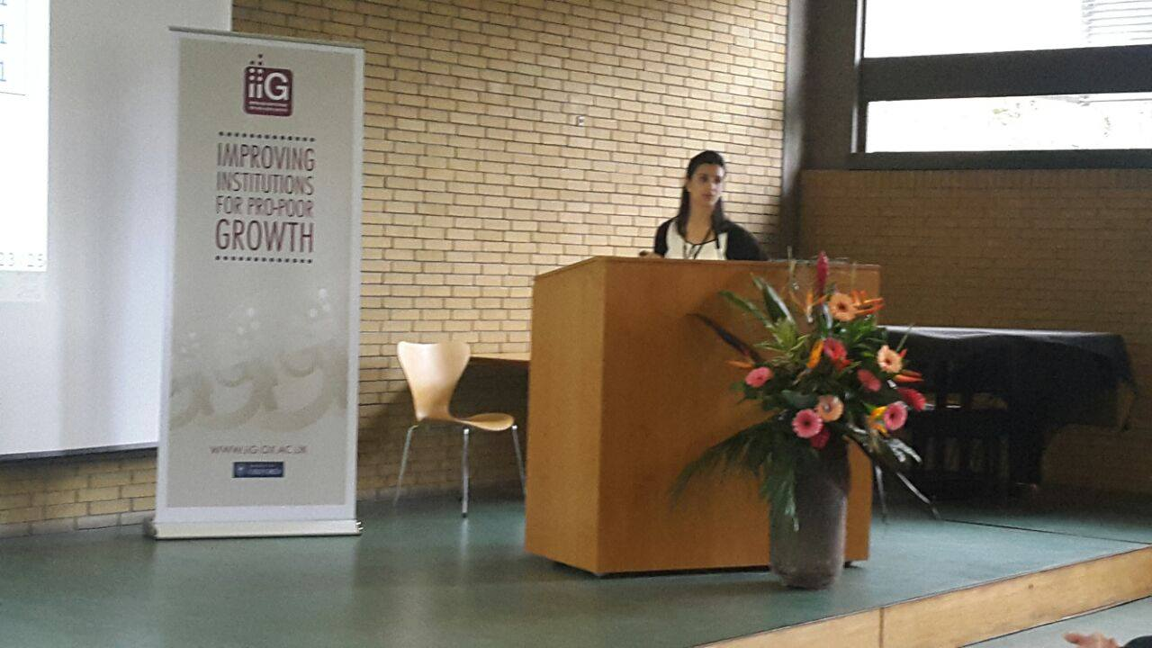

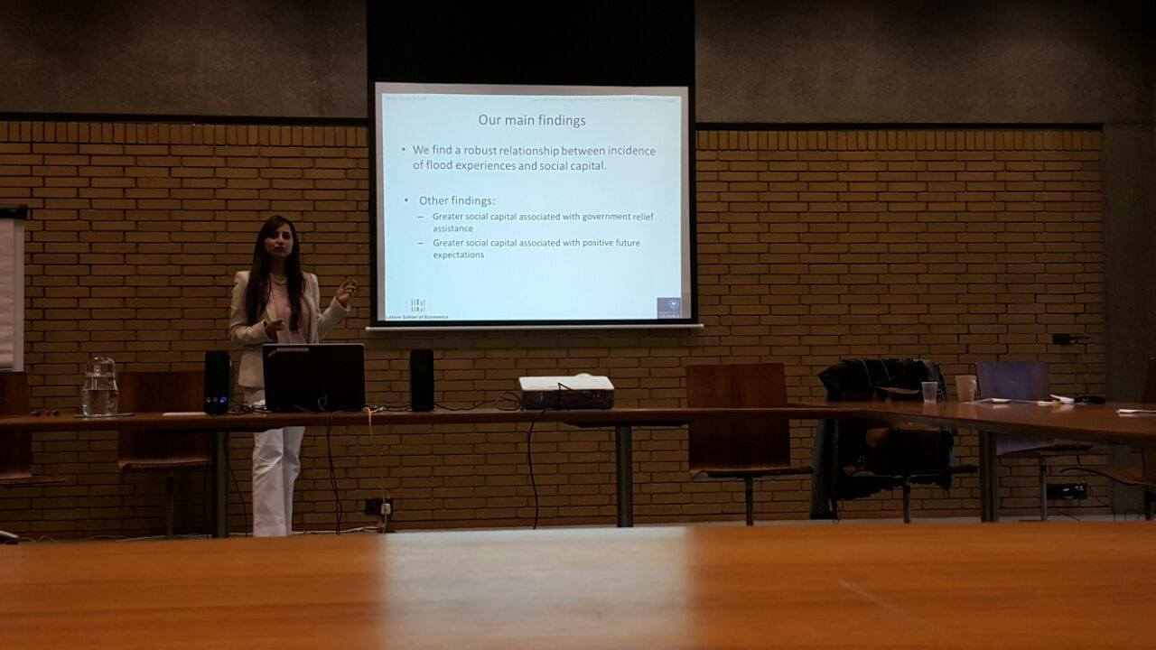

**­­­­­­­­­­­­­­­­­­**

**­­­­­­­­­­­­­­­­­­­­­­­­­­­­­­­­­­­­­­­­______________________________________________________________________________Lahore School Faculty Members attend ADB 3ie Conference**

The research fellows at the Center for Research in Economics and Business (CREB), Lahore School of Economics, presented their on-going projects at the ADB 3ie Conference on [**Making Impact Evaluation Matter**](http://impactevaluation2014.org/) held on September 3-5, 2014 in Manila, Philippines. With more than 400 participants and speakers, this was the first large scale, global impact evaluation conference in the region. Speakers for the plenary sessions and panel discussion included distinguished international figures from the field of impact evaluation and policy making. Conference sessions covered a range of topics and impact evaluations being conducted in the field of health, education, community development, governance, climate change, poverty alleviation and other aspects of social development. The conference was preceded by 2.5 days of pre-conference workshops on September 1-3, 2014.

**[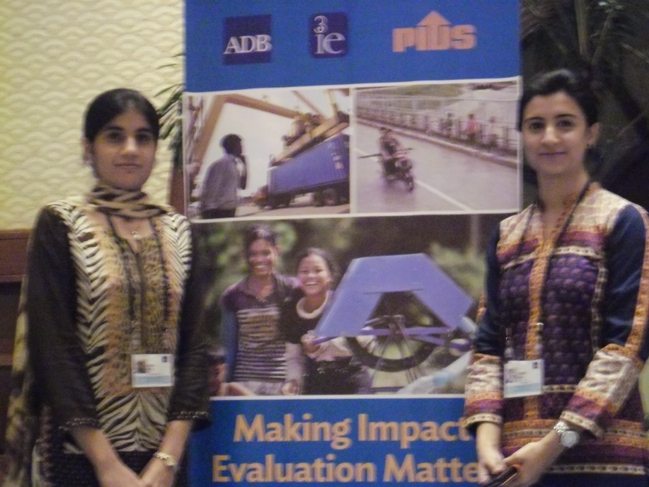](http://4.bp.blogspot.com/-0FfEy7KQMoI/VBLEm3gNtbI/AAAAAAAALaw/WDRa-keZHME/s1600/s+a+j+shirazi.jpg)**

Farah Said (Lahore School of Economics) presented the design of a study that is joint work with Mahreen Mahmud (University of Kent). The study is a Randomized Control Trial involving business loans provided to women in households where no female run enterprise exists currently. The study is being conducted in selected districts of Punjab, Pakistan in collaboration with Kashf, one of the largest private sector microfinance providers in the country and is expected to inform policy making by investing in a product that is targeted to draw new clients into their client pool.

Asha Gul (Lahore School of Economics) presented the design of the Randomized Control Trial being funded by the Pakistan Poverty Alleviation Fund (PPAF) and is an academic collaboration with Hamna Ahmed (University of Kent), Kate Vyborny (Duke University) and Simon Quinn (University of Oxford). This study focuses on incentivizing development across almost 800 Third Tier Community-based Organizations spread across Pakistan by testing the impact of two sustainable measures the donor can take to engage with these organizations: (i) self-reporting and (ii) non-financial incentives. The Baseline Survey for this study is presently being undertaken and expected to be completed by October 2014.

­­­­­­­­­­­­­­­­­­­­­

**Lahore School Paper presented at Pakistan Institute of Development Economics Generates Attention**

According to a recent case study by Zunia Saif Tirmazee and Mariyiam Haroon of the [**Lahore School of Economics**](http://www.lahoreschoolofeconomics.edu.pk/) presented at a Pakistan Institute of Development Economics (PIDE) seminar earlier this month, income distribution has been inequitable.

Pakistan has experienced tremendous economic growth over the last decade, but this did not reduce poverty and inequality. While discussing two indicators — efficiency and equity — the paper explained that efficiency required the overall improvement and equity required the improvement to be equitably distributed across various segments of the population.

Pakistan and the IMF, for the first time, seem to be almost on the same page about the current year’s economic growth forecast, despite the downside risks from militancy, monsoon floods and energy constraints.

While the government maintains its stance on achieving the 5.1pc growth rate target this year, the IMF expects it to rise to 5pc of GDP in the medium-term from last year’s 4.14pc due to easing of fiscal adjustment and improvements in the energy sector, public enterprises and investment climate.

This means that the country is now entering its average growth band of 5-6pc after a gap of seven years. It is estimated that the economy has the potential to reach 8-10pc growth in 5-6 years, provided the energy and security situation is improved and structural corrections are made sooner than later.

In the past too, Pakistan had seen swings in growth. But did this growth translate into an improvement in the lives of the majority of the population?

Most economists are not much impressed by the inclusiveness of past growth cycles, and strongly suggest that the government put in place policies at the beginning of another growth crest to benefit a majority of the people, rather than only a few.

According to a recent case study by Zunia Saif Tirmazee and Mariyiam Haroon of the [**Lahore School of Economics**](http://www.lahoreschoolofeconomics.edu.pk/) presented at a Pakistan Institute of Development Economics (PIDE) seminar earlier this month, income distribution has been inequitable.

Pakistan has experienced tremendous economic growth over the last decade, but this did not reduce poverty and inequality. While discussing two indicators — efficiency and equity — the paper explained that efficiency required the overall improvement and equity required the improvement to be equitably distributed across various segments of the population.

The paper revealed that there has been an overall improvement as indicated by an upward shift of the concentration curve, but concentration curves got steeper over time, indicating efficiency without equity.

Between 2008-09 and 2010-11, the average per capita income was higher than the social mobility index, implying that income distribution was inequitable. And the income equity index is less than one across all regions for both years, which depicts a high level of inequality. However, the magnitude of inequality varied across regions.

The paper also noted that growth in per capita income was achieved at the expense of equity. This meant that increasing incomes were being channeled towards higher expenditures and were not facilitating savings. The paper concluded that growth was not inclusive since it was achieved at the expense of equity — as the benefits of growth were unevenly distributed, with the poor benefiting less than the rich.

Perhaps mainly because of this reason, the country is far from achieving 16 targets of the Millennium Development Goals set for 2015. These particularly relate to universal primary education, reduction in extreme poverty and hunger (notwithstanding major contribution by an effective BISP), gender equality and women empowerment and lowering of child mortality rates.

Over 12m children are still out of school. Half of young children are under nourished and more than 39m people are still defined as poor. And the population growth rate of 2pc suggests that Pakistan would become the 5th most populous nation by 2050, further constraining limited resources. The youth bulge is already emerging more as a challenge than a dividend.

The Human Development Index has put Pakistan at 146 out of 187 countries. India and Bangladesh improved to 135 and 142 respectively.

Launched in July, the planning commission’s Vision 2025 recognised these challenges and hinted at pursuing steps to achieve the goal of private sector-led growth for a competitive economy and sustainable growth.

**­­­­­­­­­­­­­­­­­­­_____________­­­­­­­­­_________________________________________________________________**

**South Asian Economics Students’ Meet**

The 11th South Asian Economics Students’ Meet (SAESM) was held in Thimpu, Bhutan from December 23-26, 2014. Seven countries participated in the event with each having a 10 member delegation. Team Pakistan comprised of undergraduate students the Lahore School of Economics and other universities.

**[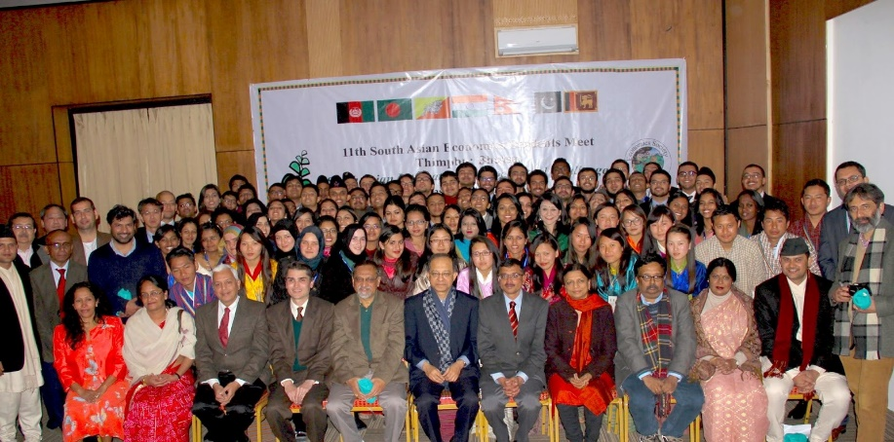](http://2.bp.blogspot.com/-tTMZdeMZMec/VLSTM0B2fxI/AAAAAAAAMNo/97pnZBfWYRE/s1600/LAHORE+SCHOOL.jpg)**

The students competed in three different events: Research Paper Submission and Presentation, Budding Economist Competition and Team Quiz Competition. Azeem Arslan Hassan, BSc IV (B) and President of the Lahore School Economics Society, presented a paper on the sub-theme “Trade Facilitation and Competitiveness in South Asia”, and won the “Best Paper Award.”

**[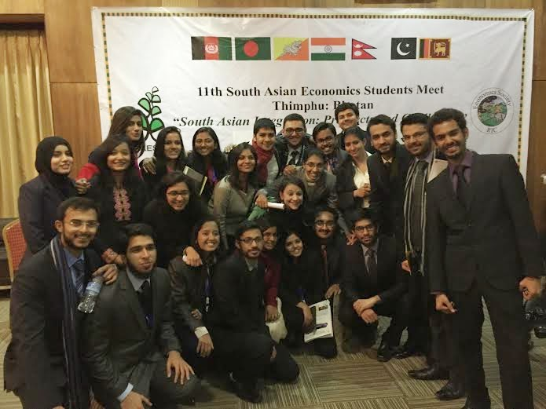](http://3.bp.blogspot.com/-wTsgxrWsWZY/VLSTWPEKlPI/AAAAAAAAMNw/y4zrq66vENA/s1600/lse.jpg)**

Mehak Anjum Siddiquei, BSc IV (C), also presented a paper on the sub-theme “FDI and Technological Transfers within South Asia”, whereas Rohail Ashraf Sadiq, BSc IV (A), represented Pakistan in the Budding Economist and team quiz competition. The Lahore School students gave impressive performances in their respective categories and received a lot of praise for their efforts. Rohail Ashraf Sadiq made it to the Semi-final round of the Budding Economist competition and was a part of the four member Pakistan team that were runners’ up in the quiz competition. The students attended three days of academic activities and also enjoyed two days of retreat in Paro, Bhutan from 27th to 29th December.

**[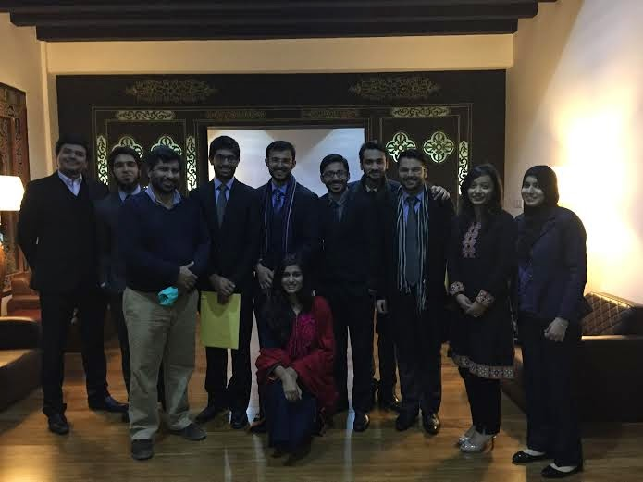](http://4.bp.blogspot.com/-mDc3GRpN_nA/VLSTgShdMqI/AAAAAAAAMN4/J8RFWzp2Fzw/s1600/lse2.jpg)**